Ohms Law.
What we now know as 'Ohm's law' appeared in the, now famous, book Die galvanische Kette, mathematisch bearbeitet (The Galvanic Circuit Investigated Mathematically (published in 1827)) in which Georg Simon Ohm (short history) gave his complete theory of electricity. Within its pages is the first known recording of the now familiar formula I = V/R written in the notation S = A/L, which is followed by the historic statement: The magnitude of the current in a galvanic circuit is directly proportional to the sum of all tensions and indirectly to the total reduced length of the circuit {translated}.
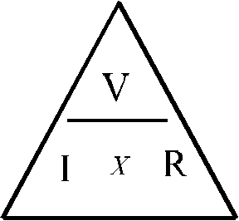
Most people tend to think of Ohms law as V = I × R
or Volts = Current (I) multiplied by (times) Resistance (Ω), often signified by the Ohms Law Triangle, shown right ("V [volts]" may be replaced by "E [Electro Motive Force, EMF]" but the meaning, in this instance, is the same).
This triangle is useful to remind us of what we need to do to find the 'missing' value. If we place a thumb over the value we need to find then what is left is how we calculate the answer.
Example: We have a circuit that has a resistance of 100Ω being supplied with 10V, what current should flow if no fault exists?
Cover the 'I' on the triangle (current) and you are left with 'V/R', or ,Volts divided by Resistance, (10/100=0.1amp or 100 milliamps).
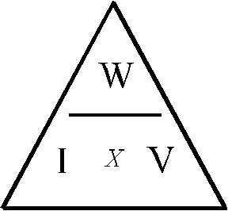
But this is only the beginning! There is no mention of power yet and without power you can't do much work. Another triangle is used to help us to remember how to calculate the power, or work being done. The equation is Watts = Current (I)×Volts (W = I × V).
This one is frequently remembered as 'IV Watts'
(the equation being swapped around does not alter the calculation at all) - I × V = Watts ("W [watts]" is sometimes replaced by "P [power]" but the meaning is the same).
Used the same way as the other triangle we can easily, for example, calculate the fuse needed for a piece of equipment.
Example: We have a power supply that, on its rating plate, states that it is 220V 500W.
Cover the 'I' on the triangle (current) and you are left with 'W/V', or ,Watts divided by Volts, (500/220=2.27 amps), as you cannot normally get a 2.27 amp fuse a 3 amp fuse would be suitable.
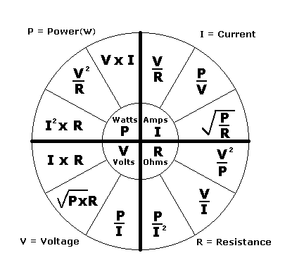
But what if we have say, the Resistance and Current (I) and need to calculate the Wattage? Well we could start by calculating the Voltage (top triangle) then use this along with the Current in the bottom triangle, but Georg was a clever chap and found the relationships between all 4 values, shown in the wheel below:
To use the wheel you find the 'missing value' in the middle and look to the outer edge to find the 2 values you have, then calculate.
Example: We have a piece of equipment bought at a rally, it has no Voltage marked on it but the fuse holder is marked '3 Amps', elsewhere it is marked 'Power consumption: 96 Watts'.
In the middle of the wheel we find the V, looking to the outer ring in that section we find the formula with I and W (or P) which we find is P/I so: 96/3 is 32 Volts. (This is just an example as the fuse will be rated higher than actual current use, but it gives you a start at tracking the correct voltage).
An important point to note is that you must use the correct units of measurement for the calculations or you will get incorrect answers. You must use Amps, Ohms, Volts and Watts. If you have kiloOhms, milliVolts etc. you must convert first.
Common Values.
Prefix | Letter | Multplier | Scientific
Mega | M (capital M) | 1 000 000 | 10⁶
Kilo | k (lower case k) | 1 000 | 10³
Milli | m (lower case m) | 0.001 | 10⁻³
Micro | μ (lower case u with a leading tail)  (properly lower case mu from Greek alphabet) | 0.000 001 | 10⁻⁶
Nano | n (lower case n) | 0.000 000 001 | 10⁻⁹
Pico | p (lower case p) | 0.000 000 000 001 | 10⁻¹²
You probably won't come across nano and pico in relation to Ohms law.
I have included them for completeness.

