Coax Explained
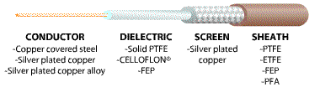
Coaxial cable is an electrical cable consisting of a round, insulated conducting wire surrounded by a round, conducting sheath, usually surrounded by a final insulating layer. It is designed to carry a high-frequency or broadband signal, usually at radio frequencies.
Coaxial Cabling is a two conductor, unbalanced, closed transmission medium that is used for the transmission of RF energy. It yields excellent performance at high frequencies and superior EMI control/shielding when compared to other types of copper cabling.
Listed below are some common terms and definitions that are related to coaxial cabling:
Attenuation (Insertion Loss)
Loss of power. Attenuation is usually measured in dB loss per length of cable (ex. 31.0 dB/100Ft.). Attenuation increases as frequency increases.
BALUN
An acronym for BALanced/UNbalanced. A device commonly used to change one cabling media to another (ex. coaxial to Ladder Line balun).
Center Conductor
The solid or stranded wire in the middle of the coaxial cable. The conductor diameter is measured by the American Wire Gauge (AWG).
Coaxial Adaptor
A device used to change one connector type to another or one gender to another (ex. BNC to SMA Adaptor).
Coaxial Cable
A two conductor cylindrical transmission line typically comprised of a center conductor, an insulating dielectric material and an outer conductor (shielding). Coaxial cable can be flexible, semi-rigid or rigid.
Coaxial Connector
The interconnection device found at each end of a coaxial cable assembly. There are many common types of coaxial connectors such as: BNC, SMA, SMB, F, PL259, N.
Dielectric
The insulating material that separates the center conductor and the shielding.
Electromagnetic Interference (EMI)
Electrical or electro-magnetic energy that disrupts electrical signals.
Frequency
The number of times a periodic action occurs in one second. Measured in Hertz.
Impedance
The opposition to the flow of alternating or varying current. Measured in Ohms.
Jack
The female connector usually containing a center socket.
Plug
The male connector usually containing a center pin.
RG/U
Symbols used to represent coaxial cable that is built to U.S. government specifications (R=Radio Frequency, G=Government, U=Universal Specification).
Shielding
Conductive envelope made of wires or metal foil that covers the dielectric and the center conductor.
(V)SWR ((Voltage) Standing Wave Ratio)
Amount of reflected power expressed as a ratio (Ex. 1.25:1) VSWR increases as frequency increases.

STANDARD CABLE TYPES
Most coaxial cables have a characteristic impedance of either 50 or 75 ohms. The RF industry uses standard type-names for coaxial cables. The U.S military uses the RG-# or RG-#/U format.
Detailed comparison of typical coaxial cables
Type |  | RG-316 | RG-174 | RG-58/U | RG-59 | RG-213/UBX | RG-213 FOAM | AIRCELL 7 | BELDEN  H-155 | BELDEN  H-500 | ---
Impedance |  | 50 | 50 | 50 | 75 | 50 | 50 | 50 | 50 | 50 | Ohm
Outer diameter |  | 2.6 | 2.6 | 5.8 | 6.2 | 10.3 | 10.3 | 7.3 | 5.4 | 9.8 | mm
Loss at | 30 MHz | 18 | 20 | 9.0 | 6.0 | 1.97 | 3.7 | --- | 3.4 | 1,95 | dB/100m
 | 144 MHz | 32 | 34 | 19 | 13.5 | 8.5 | 4.94 | 7.9 | 11.2 | 4.9 | dB/100m
 | 432 MHz | 60 | 70 | 33 | 23 | 15.8 | 9.3 | 14.1 | 19.8 | 9.3 | dB/100m
 | 1296 MHz | 100 | 110 | 64.5 | --- | 28 | 18.77 | 26.1 | 34.9 | 16.8 | dB/100m
 | 2320 MHz | 140 | 175 | --- | --- | --- | 23.7 | 39 |  | 24.5 | dB/100m
Velocity factor |  | 0.7 | 0.66 | 0.66 | --- | 0.66 | 0.8 | 0.83 | 0.79 | 0.81 | ---
Max. load at | 10 MHz | 900 | 200 | --- | --- | --- | 2000 | 2960 | 550 | 6450 | W
 | 145 MHz | 280 | 9 | --- | --- | --- | 1000 | 1000 | 240 | 1000 | W
 | 1000 MHz | 120 | 30 | --- | --- | --- | 120 | 190 | 49 | 560 | W
As you can see, the common RG-58 from your local emporium is NOT the best you can do and will lower your output power by the time it reaches the antenna, so use it only for short runs.
So where does all this lost power go? Its dissipated as heat inside the cable. With a 100W transmitter you'll already notice your RG58 heating up after several minutes of transmission which is definitely not what you want.
Watch out for the correct impedance:- RG-8 and RG-58 have 50 Ohm impedance, whilst RG-59 and RG-6 (Low Loss Version of RG-59) have 75 Ohm impedance. Many antennas are 50 ohm impedance and so are most transmitters.
Don't fit more than you need to make the long run to your antenna as coiling can alter the SWR and possibly be a trip hazard. Also don't make up a few "patch cables" to go between your radio, VSWR meter and your antenna as all you'll do is create higher SWR and more line losses. Finally, don't use cheap TV cable (I have seen it done!).
COMMON CONNECTOR TYPES (photos not to scale)
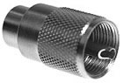
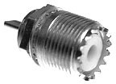
"UHF" connector or PL259/SO239
The "UHF" connector is the old industry standby for frequencies above 50 MHz (during World War II, 100 MHz was considered UHF). The UHF connector is primarily an inexpensive all purpose screw on type that is not truly 50 Ohms. Therefore, it's primarily used below 300 MHz. Power handling of this connector is 500 Watts. The frequency range is 0-300 MHz although a lot of commercial amateur equipment uses this connector on 430-440 MHz.
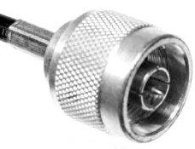
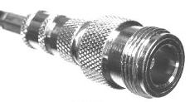
"N" connectors
"N" connectors were developed at Bell Labs soon after World War II so it is one of the oldest high performance coax connectors. It has good VSWR and low loss through 11 GHz. Power handling of this connector is 300 Watts to 1 GHz. The frequency range is 0-11 GHz.
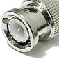
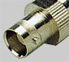
"BNC" connctor:
BNC connectors have a bayonet-lock interface which is suitable for uses where where numerous quick connect/disconnect insertions are required. BNC connectors are for, example, used in various laboratory instruments and radio equipment. BNC connector has much lower cut-off frequency and higher loss than the N connector. BNC connectors are commonly available in 50 ohm and 75 ohm versions.
Power handling of this connector is 80 Watts at 1GHz. The frequency range is 0-4 GHz.
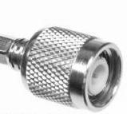
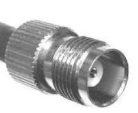
"TNC" connectors
TNC connectors are an improved version of the BNC with a threaded interface. Power handling of this connector is 100 Watts at 1 GHz. The frequency range is 0-11 GHz.

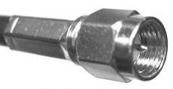
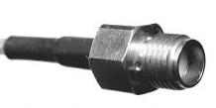
"SMA" connector:
SMA or miniature connectors became available in the mid 1960's. They are primarily designed for semi-rigid small diameter (0.141" OD and less) metal jacketed cable, they are also found on smaller handheld equipment for connecting the antenna. Power handling of this connector is 100 Watts at 1 GHz. The frequency range is 0-18 GHz.

