Directional Antennas.
A Beginners Explanation.
All antennas radiate some energy in all directions in free space but careful design can result in a substantial transmission of energy in a preferred direction and negligible energy radiated in other directions. This directivity has two big advantages over dipole and vertical antennas.
- A beam antenna concentrates most of its transmitted signal in one direction. Gain is provided in the direction the antenna is pointed.
- There is a reduction in the strength of signals coming from directions other than the maximum gain direction.
This makes your signal sound stronger to other operators and theirs stronger to you, when compared with non-directional antennas and, by reducing the interference from other directions, you can often hear other stations that would otherwise be unreadable.
A point to note here is that you don't actually 'Gain' any power, the 'extra' is what is redirected from the sides and rear of the antenna.
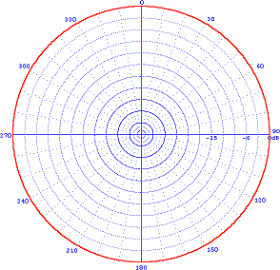
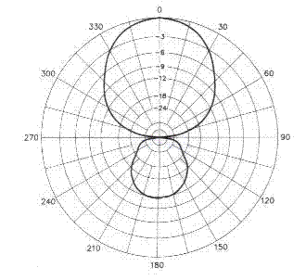
A beam antenna's radiation pattern can be found on a graph of the antenna's gain and directivity. The first diagram below shows the radiation pattern of a typical vertical monopole antenna, as viewed from above. The second diagram shows the radiation pattern of a typical horizontally polorisied Yagi beam antenna, also from above:
You can see by the red line that the radiation pattern is uniform for the Monopole Antenna (left), whereas the Yagi pattern (right) has 'lost' a lot of side and rear radiation which has been 'transferred' to the frontal or main lobe.
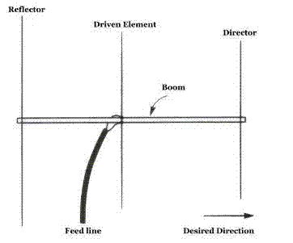
As you can see in the diagram on the right, the Yagi beam has several elements attached to a central boom. These elements are placed in a straight line along the boom and are parallel to each other. The boom length has the largest effect on gain in a Yagi antenna, the longer the boom the higher the gain.
The feed line connects only to the driven element. On a three element Yagi, like the one shown, the driven element is located in the middle.The driven element is one-half wavelength long at the antennas' intended frequency.
The element located at the front of the antenna, nearest the favoured direction, is called the director and is smaller than the driven element, there may be more than one director, the more directors the higher the gain.
The element located directly behind the driven element is called the reflector and is larger than the driven element.
Although Yagi antennas can have more than three elements, rarely is there ever more than one reflector. The directors and reflectors are also known as parasitic elements, because they are not fed directly. You may hear beams referred to as "parasitic beam antennas" and that is the reason.
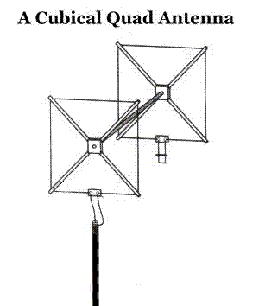
In a beam antenna the direction of maximum radiation is from the reflector to the director. The region of maximum radiation from a directional antenna is referred to as the "major lobe" or "main lobe". You may communicate in different directions with a beam antenna simply by rotating the array in the horizontal plane to point it in the desired direction.
The cubical quad antenna (commonly referred to as a "quad") also uses parasitic elements. The elements of a quad are usually just simple wire loops. The total length of the wire in the driven element is approximately one electrical wavelength. In a typical quad, as shownbelow, there are two elements, a driven element and a reflector. A two element quad could also be constructed with a driven element and a director, rather than a reflector. More elements can always be added to the design, such as a reflector and/or one or more directors. The typical radiationpattern of a quad antenna is very similar to that of the Yagi shown in the diagram above. Each element of the quad is usually square in shape, with each of these element loops being one electrical wavelength. Each side of the square would then be one quarter wavelength long.
Polarisation on a quad antenna is determined by where the feed point is located on the driven element, making it possible to change the polarisation of the signal. If the feed point is located in the center of one of the vertical sides, the transmitted wave would be vertically polarised, just as if the feed point was located in the center of a horizontal side, the waves would be horizontally polarised. This type of antenna can also be turned 45 degrees so that it resembles the shape of a diamond, at which point if it was fed at the side corner, the transmitted wave would be vertically polarised. In this same manner, if it was fed at the bottom corner, the transmitted wave would be horizontally polarised. The picture below shows both types of horizontal polorisation.
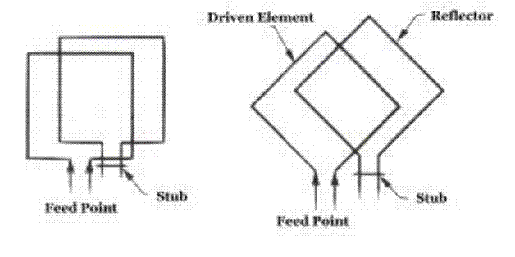
A delta loop antenna, as shown below, is very similar to the quad antenna. The delta loop antenna has triangular elements rather than square elements, although the total loop length is still one wavelength. You must divide the total length by three to find the length of each side element. As with the quad, the radiation pattern of the delta loop is very similar to the pattern of the Yagi as shown above.
